Agriculture Drought monitoring using time series satellite data on Google Earth Engine



M.sc.(Agriculture Analytics)

Submitted by:

Mit Borda (daiict202319008)

Kaushal Kathiriya (daiict202319013)

Submitted To:

Project Guide : Mr. Abhishek Danodia

Course Co-ordinator : Dr. N.R.Patel

(Agriculture & Soil Department)

Contents

|  |  |  |
| --- | --- | --- |
| **Sr. No.** | **Title** | **Page No.** |
| i | **Abstract** | 4 |
| ii | **Acknowledgement** | 5 |
| 1 | **Introduction** | 6 |
| 2 | **Literature review** | 12 |
| 3 | **Materials** | 15 |
| 4 | **Methodology** | 21 |
| 5 | **Results** | 29 |
| 6 | **Conclusion** | 31 |
| 7 | **References** | 32 |

LIST OF FIGURES

|  |  |
| --- | --- |
| Figure:3.1 | Multidimensional impacts of drought |
| Figure:4.1 | The fowchart of methodology used in the study |
| Figure:4.2 | Yearwise VCI Variation (2000-2023) |
| Figure:4.3 | Yearwise TCI Variation (2000-2023) |
| Figure:4.4 | Yearwise PCI Variation (2000-2023) |
| Figure:4.5 | Yearwise CDI Variation (2000-2023) |
| Figure:5.1 | Drought Year V/S Normal Year |

LIST OF TABLES

|  |  |
| --- | --- |
| Table:3.1 | Description of the dataset used for this study of multi-aspect drought-severity monitoring and assessment |
| Table:4.1 | Formulas for the Indices |
| Table:4.2 | Classification of Drought by calculated the TCI,VCI,PCI,CDI |
| Table:5.1 | Mean Combined Drought Index values by district for drought monitoring |

1. **ABSTRACT**

Agricultural drought, a phenomenon resulting from prolonged dry weather causing water scarcity, poses significant challenges to farmers, rural communities, and global food security. Accurate prediction of agricultural drought is crucial for effective water resource management, crop planning, and risk mitigation strategies. In recent years, there have been significant advancements in remote sensing, climate modelling, and data analytics, which have enabled the development of sophisticated techniques for agricultural drought prediction.

This report provides an in-depth overview of agricultural drought monitoring & assessment, its importance for sustainable agriculture, and food security. It reviews relevant literature and case studies on agricultural drought assessment models, including remote sensing-based approaches, statistical methods, and machine learning algorithms. The report discusses the impacts of climate change on agricultural drought and highlights the potential of agricultural drought monitoring in contributing to sustainable agricultural practices and natural resource management.

Furthermore, the report identifies the challenges and limitations of agricultural drought prediction, such as data availability, weather and climate complexities, and adoption barriers in developing regions. Recommendations for further research and improvement of agricultural drought prediction tools are provided. The report concludes with the potential of agricultural drought monitoring to enhance farmers' resilience to drought impacts, support policymakers in developing appropriate mitigation strategies, and contribute to sustainable agriculture and food security.

Overall, this report aims to provide valuable insights for researchers, policymakers, and stakeholders interested in agricultural drought monitoring & assessment, its applications, challenges, and future directions.

2. Acknowledgements

First and foremost, we would like to express our sincere gratitude to our project guide, Mr. Abhishek Danodia, at the Indian Institute of Remote Sensing (IIRS). His expertise in agricultural geospatial data proved invaluable in shaping the direction and methodology of this drought monitoring & assessment report. His ability to provide valuable insights and information on applying this data to our project was instrumental. His dedication and willingness to answer our questions were essential in ensuring the quality of our work.

We are also grateful to Dr. N.R. Patel, our course coordinator and Head of the Agriculture Department. Dr. Patel's expertise in the agriculture sector provided a strong foundation for this project. We are thankful for his support and for providing us with the necessary resources to undertake this study.

Signature

Mitkumar Borda

Kaushal Kathiriya

1. Introduction

Drought is a climatic anomaly, characterized by deficient supply of moisture resulting either from sub-normal rainfall, erratic rainfall distribution, higher water need or a combination of all the three factors Several definitions of drought are available in literature In India, National Commission on Agriculture (1976) has categorized drought into three types, viz., meteorological drought, hydrological drought and agricultural drought based on the concept of its utilization.

In meteorological terms, a drought is "a sustained, regionally extensive, deficiency in precipitation". All other definitions are related to the effect or impact of below normal precipitation on water resources, agriculture and social and economic activities, hence the terms hydrological drought and agricultural drought. In quantitative terms, the definitions could vary among countnes and regions. In India, the definition for "meteorological drought adopted by the Indian Meteorological Department (IMD) is a situation when the deficiency of rainfall at a meteorological sub-division level is 25 per cent or more of the long-term average (LTA) of that sub-division for a given penod. The drought is considered "moderate", if the deficiency is between 26 and 50 per cent, and "severe" if it is more than 50 per cent. Based on this definition, the National Commission on Agriculture has given the following broad classifications.

Hydrological drought is a prolonged meteorological drought situation resulting in depletion of surface water from reservoirs, lakes, streams, rivers, cessation of spring flow and fall in groundwater levels causing severe shortage of water for livestock and human needs.

Agricultural drought is a situation when rainfall and soil moisture are inadequate during the crop growing season to support healthy crop growth to maturity, causing crop stress and wilting. It is defined as a period of four consecutive weeks (of severe meteorological drought) with a rainfall deficiency of more than 50 per cent of the LTA or with a weekly rainfall of 5 cm or less during the period from mid-May to mid-October (the Kharif season) when 80 per cent of the country's total crop is planted, or six such consecutive weeks during the rest of the year The National Oceanic and Atmospheric Administration (NOAA) defines agricultural drought as a combination of temperature and precipitation over a period of several months leading to substantial reduction (less than 90%) in yield.

Drought differs from other natural hazards in many respects most complex and least understood of all disasters. While it is difficult to demarcate the onset and end of drought but the effects of drought accumulate for a considerable period of time. Prolonged droughts or abnormal weather conditions such as extended winters, cold summers, floods, biological factors like plague of locusts or rodents result in famines.

This project is about Agricultural drought Monitoring & Assessment.

**1.1 Drought impacts - the vicious circle**

Practically all the developing countries, being primarily agrarian, are very much dependent on the vagaries of seasonal rainfall and climatic conditions. On an average, severe drought occurs once every five years in most of the tropical countries, though often they occur on successive years causing misery to human life and live stock. The crisis brought out by this hazard directly hit poorest and most deprived sections of our society thus destroy the life, economy, infrastructure, environment and society because all are inter linked.

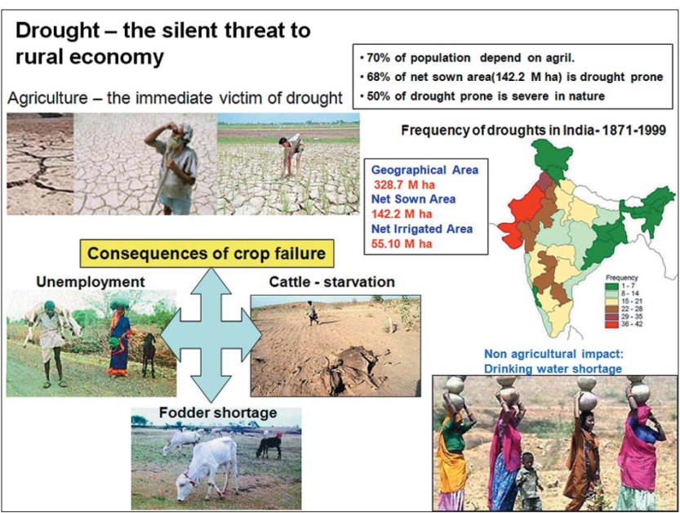

Figure:1.1 *Multidimensional impacts of drought*

Drought results from adverse (figure:1.1) climatic conditions leading to deleterious impacts on various sectors of the economy. The immediate impact is on crop area, crop production and farm employment. Reduction in income and purchasing power of farmers forces the small and marginal farmers to join the band of agricultural labourers leading to increase in unemployment. Speculation of poor farm harvest drives the food prices upwards. Market failure and advantage-seeking group work in perfect nexus to intensify the impact of drought. The effect of this nexus are catastrophic particularly to small and marginal farmers who constitute the large chunk of farming community, who tend to migrate obviously to urban areas in search of employment opportunities. Shortage of drinking water and starvation for food are the other consequences that emerge. Fodder problem drives away the animals to distress sales. Thus, climate is the initial causative factor for drought, the implications and intensity of drought are manifested by human interactions with the situation leading to famines.

Indian economy is largely dependent on agriculture with more than 70% of the population depending either directly or indirectly on agriculture for their livelihood. Owing to abnormalities in the monsoon precipitation, in terms of spatial and temporal variation, especially, late onset of monsoon, prolonged break and early withdrawal of monsoon, drought is a frequent phenomenon over many parts of India. About two thirds of the geographic area of India receives low rainfall (<1000 mm), which is also characterized by uneven and erratic distributions. Out of net sown area of 140 million hectares about 68% is reported to be vulnerable to drought conditions and about 50% of such vulnerable area is classified as 'severe', where frequency of drought is almost regular. India experiences localized drought almost every year in some region or other. In the post-independence era, major droughts that affected more than 1/3rd of the country were reported during 1951, 1966-67, 1972, 1979, 1987-88 and 2002-03 (Subbaih 2004). Thus, despite significant technological advances since independence, Indian agriculture continues to be periodically affected by droughts.

Abnormally low rainfall in 1979, reduced the overall food grain by as much as 20%. The 1987 drought damaged 58.6 million hectares of cropped area affecting over 285 million people. The 2002 drought had reduced the sown area to 112 million hectares from 124 million hectares and the food grain production to 174 million tons from 212 million tons, thus leading to 3.2% decline in agricultural GDP. The total food grain production in India has to be stepped up from 212 million metric tons to 300 million metric tons by 2025 to meet the food demands of growing population.

**1.2 Agriculture drought:**

Agricultural Drought: Prolonged dry weather with inadequate precipitation, leading to reduced crop yields, livestock losses, and negative impacts on agriculture.

Agricultural drought, a common natural disaster in many regions, is a phenomenon that occurs when there is an extended period of inadequate soil moisture, leading to reduced crop growth and yield losses. Agricultural droughts have severe implications for farmers, rural communities, and global food security, as they can result in crop failure, reduced farm income, and increased vulnerability to poverty and hunger.

Agricultural droughts are influenced by various factors, including climate variability, such as changes in precipitation patterns and temperature, as well as soil moisture dynamics and crop water requirements. Accurate prediction of agricultural drought is crucial for effective water resource management, crop planning, and risk mitigation strategies. Over the years, there have been significant advancements in remote sensing, climate modelling, and data analytics that have enabled the development of sophisticated techniques for agricultural drought prediction.

This report aims to provide an in-depth overview of agricultural drought, its causes, impacts, and prediction methods. It will discuss the importance of agricultural drought prediction for sustainable agriculture and food security, and highlight the current state of the field, including advancements and challenges. The report will review relevant literature and case studies on agricultural drought prediction models, including remote sensing-based approaches, statistical methods, and machine learning algorithms. It will also explore the application of agricultural drought prediction in different regions and crop systems. Finally, the report will provide recommendations for further research and the adoption of agricultural drought prediction tools for effective drought management and resilient agriculture practices.

In recent years, the increasing frequency and intensity of climate change-related events have further heightened the need for accurate and timely agricultural drought prediction. Climate change has led to changes in precipitation patterns, temperature, and extreme weather events, which can exacerbate drought conditions in agricultural regions. As a result, farmers and policymakers need reliable prediction tools to anticipate and respond to potential agricultural drought impacts, such as adjusting planting dates, optimizing irrigation, and implementing drought-resistant crop varieties. Agricultural drought prediction can also aid in the development of drought contingency plans and policies, including early warning systems, drought monitoring, and resource allocation, to mitigate the adverse effects of drought on agriculture and rural livelihoods.

In conclusion, accurate prediction of agricultural drought is crucial for effective drought management, sustainable agriculture, and food security. Advancements in remote sensing, climate modelling, and data analytics have enabled the development of sophisticated techniques for agricultural drought prediction, which can aid farmers, policymakers, and other stakeholders in making informed decisions and taking proactive measures to mitigate the impact of drought on agriculture. By providing timely and accurate information about drought conditions, agricultural drought prediction can contribute to improved water management, optimized agricultural practices, and resilient agricultural systems, ultimately helping to ensure food security and sustainability in the face of changing climate conditions.

However, there are also challenges associated with agricultural drought prediction, such as the availability and quality of data, the complexity of weather and climate interactions, and the need for localized prediction models that account for regional variations. Additionally, the adoption of agricultural drought prediction tools in developing regions and by smallholder farmers may require overcoming technical, financial, and capacity limitations.

**1.3 Approach of the Study**:

The study focuses on Gujarat.

**1.4 Drought Statistics in Gujarat**:

Gujarat state was formed in the year 1960 when the erstwhile bilingual Bombay State was split into two separate states; Gujarati speaking Gujarat State and Marathi speaking 6Maharashtra state. With its enterprising population and committed leadership Gujarat has done well since then in terms of overall economic growth. It has progressed to acquire the 4th rank in per capita income among the major states in India and has maintained this rank for the last two decades or so. Today it is one of the prosperous states of India with about 50 million population (2001) spread over 196,000 sq. km. The state gets highly unevenly distributed rainfall, varying from 300 – 350 mm in Kachchh to 600 – 700 in Saurashtra and North Gujarat to more than 1500 mm in South Gujarat. The low rainfall in many parts of the state is highly erratic in nature. Gujarat is a highly drought prone state. Out of the total 184 talukas (old talukas), 52 talukas are covered under the DPAP (Drought Prone Area Programme) and 47 talukas are covered under the DDP (Desert Development Programme)1. That is, about 99 talukas and more than 60 per cent of the area of the state is subjected to frequent droughts. In major droughts, some additional areas also suffer from poor rainfall. The incidence of droughts is quite high in the state. In every five years, 2-3 years are drought years and in every ten years there are 2-3 severe and widespread droughts, which are frequently consecutive. In normal years also about 10 to 15 per cent of talukas are declared drought affected and scarcity works are undertaken here. It has been observed that the frequency and intensity of droughts have increased in the state over the years. However, deaths due to famines are almost eradicated, as food grains are made available to drought-affected people. A few deaths, however, have been reported on scarcity works due to other reasons. The other change is that the droughts now are accompanied by serious drinking water shortages. This is because of severe depletion of water resources in the state in the recent decades. Till about the sixties and seventies it was possible to dig wells/bores/tube wells to access drinking water.

2. Literature review

Agricultural drought monitoring and assessment are important topics in the field of agriculture and remote sensing. Here is a brief review of the literature related to agriculture drought monitoring and assessment.

Dipanwita Dutta, Arnab Kundu, N.R. Patel, S.K. Saha (2015) Assessment of agriculture drought in Rajasthan using remote sensing derived vegetation condition index and standardized precipitation index.

* This review article provides an overview of the current methods and opportunities for remote sensing-based agricultural drought assessment. It discusses various remote sensing data sources, such as satellite images, and their applications i monitoring drought impacts on agricultural crops. The article also highlights the advantages and limitations of different remote sensing techniques for drought assessment, including vegetation indices, thermal remote sensing, and microwave remote sensing.

N.R. Patel, B.R. Parida, V. Venus, S.K. Saha, V.K. Dadhwal (2012) Analysis of agricultural drought using vegetation temperature condition index (VTCI) from Terra/MODIS satellite data

* Assessment of agricultural drought vulnerability using remote sensing and GIS: A case study in India: This research article presents a case study on assessing agricultural drought vulnerability using remote sensing and GIS techniques in India. It discusses the use of remote sensing data, such as MODIS vegetation indices and rainfall data, to evaluate drought vulnerability of different crops at regional and district scales.

S.K. Jain, R. Keshri, A. Goswami, A. Sarkar (2010) Application of meteorological and vegetation indices for evaluation of drought impact: a case study for Rajasthan, India

* This article presents a case study for Rajasthan, India, focusing on the application of meteorological and vegetation indices for evaluating drought impacts on agriculture. Remote sensing techniques and meteorological data are used to assess drought conditions and their impact on vegetation health. The findings highlight the usefulness of these indices in monitoring drought severity and identifying affected areas. The article contributes to the literature on agriculture drought monitoring and assessment.

F.N. Kogan (1995) Application of vegetation index and brightness temperature for drought detection.

* This article discusses the application of vegetation indices and brightness temperature for drought detection. Remote sensing techniques are used to analyse vegetation health and thermal properties to identify areas affected by drought. The findings contribute to the literature on drought monitoring and provide insights into the use of these indices for detecting drought impacts on vegetation.

E. M. Ergene , F. Bektaş Balçık , F. Balik Şanlı(2024): Trends Analysis of agricultural drought in central anatolian basin, Turkey.

* This article provides insights into the measurement of the scaled drought condition index and various index formulas, offering an overview of how time series data can be effectively managed. Additionally, it discusses the methodology for conducting trend analysis using the Mann-Kendall (MK) test and Sen's slope. By employing these statistical techniques, the study aims to assess temporal trends in agricultural drought severity, contributing to a comprehensive understanding of drought dynamics and facilitating informed decision-making in drought management.

Venkatesh Ravichandran , Komali Kantamaneni, Thilagaraj Periasamy, Priyadarsi D. Roy, Jothiramalingam Killivalavan, Sajimol Sundar, Lakshumanan Chokkalingam and Masilamani Palanisamy(2022): Monitoring of Multi-Aspect Drought Severity and Socio-Economic Status in the Semi-Arid Regions of Eastern Tamil Nadu, India

* This article discusses various types of drought and emphasizes the key variables to consider during drought monitoring and assessment. It outlines the process of aggregating these variables to derive a multidimensional drought severity index. Furthermore, it provides comprehensive information on all indices relevant to drought monitoring and assessment, facilitating a thorough understanding of the methodologies employed in evaluating drought conditions.

Abhishek Danodia, Anuradha Kushwaha,N. R. Patel:Remote sensing‐derived combined index for agricultural drought assessment of rabi pulse crops in Bundelkhand region, India

* The study introduces a novel approach for assessing drought severity in the Bundelkhand region of India, focusing on rabi season crops. It employs a Multi-Criteria Decision-Making approach, combining remote sensing data from MODIS satellite, CHIRPS rainfall data, and Era Interim soil moisture data from 2001 to 2018. By integrating various spectral indices through the Analytical Hierarchy Process, the Combined Drought Index (CDI) is established, showing a significant correlation between crop yield anomaly and CDI for rabi pulses crops. This geospatial platform-based approach, utilizing historical earth observations and expert advice, provides a realistic, efficient, and scalable methodology for assessing drought risk and severity in agricultural ecosystems.

**3. MATERIALS**

For this project we used three major datasets.

1. NDVI
2. Land Surface Temperature (LST)
3. Rainfall

NDVI, or Normalized Difference Vegetation Index, is a widely used remote sensing technique that measures the health and vitality of vegetation. It is calculated from satellite or aerial imagery by taking the normalized difference between near-infrared and red reflectance values. NDVI values range from -1 to 1, with higher values indicating denser and healthier vegetation cover.

From them first one is **NDVI** (Normalized Difference Vegetation Index) derived from MODI’s dataset from google earth engine of during kharif season means months are July, August, September, October from date 01/07/2000 to 31/10/2023 .

Satellite datasets for Land Surface Temperature (LST) provide valuable information on the thermal behaviour of the Earth's surface. These datasets are generated from thermal infrared sensors onboard satellites, which measure the emitted radiation from the land surface. Several satellite missions, such as MODIS, Landsat, and Sentinel, provide global or regional coverage of LST with different spatial and temporal resolutions.

Second one is **LST (**Land Surface Temperature**)** which is derived from MODI’s dataset from google earth engine by a script code of during kharif season means months are July, August, September, October from date 01/07/2000 to 31/10/2023.

CHIRPS (Climate Hazards Group InfraRed Precipitation with Station data) is a widely used rainfall dataset that provides global precipitation information at high spatial and temporal resolutions. CHIRPS combines satellite-derived infrared measurements with ground-based precipitation data to estimate rainfall. It covers a historical period dating back to 1981 and is regularly updated. CHIRPS data is commonly used for monitoring and analysing precipitation patterns, drought assessment, flood prediction, crop monitoring, and climate research.

And the third one is **RAINFALL(**Precipitation**)** which is also derived from **CHIRPS** satellite data from google earth engine by a script code of during kharif season means months are July, August, September, October from date 01/07/2000 to 31/10/2023 .

From these three main datasets we derived three indices **VCI** (vegetation condition index)**, TCI** (Temperature condition index), **PCI** (Precipitation condition index) which is helpful to define a agriculture drought. Now we see in the details one by one.

**3.1 Vegetation Condition Index (VCI):**

The Vegetation Condition Index (VCI) is a widely used indicator for monitoring agricultural drought. It provides a measure of the health and vigour of vegetation, which can be used to assess the impact of drought on agricultural crops and pastures. The VCI is typically calculated using satellite remote sensing data, such as Normalized Difference Vegetation Index (NDVI), which measures the amount and vigour of green vegetation.

During a drought, vegetation undergoes stress due to reduced water availability, leading to decreased growth and productivity. The VCI is used to quantify this stress and assess the severity of agricultural drought. A lower VCI value indicates poorer vegetation condition, while a higher value indicates healthier vegetation. The VCI is usually scaled from 0 to 100, with lower values indicating more severe drought conditions.

To calculate the VCI, the NDVI values are used to establish a baseline reference period, typically using historical data from a normal or non-drought year. This baseline NDVI value is then compared to the current NDVI values during the drought period. The VCI is usually expressed as a percentage, ranging from 0 to 100, with higher values indicating healthier vegetation conditions.

A higher VCI value (closer to 100%) indicates better vegetation condition, suggesting minimal or no stress due to drought. Conversely, a lower VCI value (closer to 0%) indicates poorer vegetation condition, suggesting higher stress and impacts from drought.

**V**egetation **C**ondition **I**ndex formula:

**VCI = ((NDVI - NDVImin) / (NDVImax - NDVImin)) x 100**

where NDVI represents the Normalized Difference Vegetation Index, NDVImin is the minimum NDVI value observed during a reference period (often a normal or non-drought year), and NDVImax is the maximum NDVI value observed during the same reference period.

In summary, the Vegetation Condition Index (VCI) is a useful indicator for assessing the impact of agricultural drought on vegetation health. It provides valuable information for monitoring and managing drought conditions in agricultural areas, helping to inform decision-making and mitigate the impacts of drought on crop production and food security.

**3.2 Temperature Condition Index (TCI):**

The Temperature Condition Index (TCI) is a critical parameter for monitoring agricultural drought, which is calculated using satellite-based remote sensing data, typically utilizing the Land Surface Temperature (LST) as a proxy for temperature conditions. LST refers to the temperature of the Earth's surface as measured by satellite sensors.

The TCI is derived using the following formula:

**TCI = ((LSTmax - LST) / (LSTmax - LSTmin)) x 100**

where LST represents the current land surface temperature, LSTmax is the maximum LST observed during a reference period (often a normal or non-drought year), and LSTmin is the minimum LST observed during the same reference period. In our case reference period is year 2000 to 2023 for kharif season (July, August, September, October).

The TCI formula calculates the percentage difference between the current LST value and the maximum LST value observed during the reference period, normalized by the range between the maximum and minimum LST values. The resulting TCI value ranges from 0 to 100, with higher values indicating hotter temperature conditions, and lower values indicating cooler temperature conditions.

The classification of agriculture drought using Temperature Condition Index (TCI) values can vary depending on the specific methodology and thresholds used. It's important to note that the exact TCI values and thresholds for agriculture drought classification may vary depending on the region, crops, and climatic conditions being monitored. It's recommended to consult established guidelines, methodologies, or local agricultural authorities for accurate and context-specific TCI values and thresholds for agriculture drought classification in a particular area.

The TCI serves as an important indicator of temperature stress on crops and vegetation, which can affect plant growth, development, and water requirements. Higher TCI values indicate increased temperature stress, which can lead to reduced crop yields and increased water demand. The TCI, when used in conjunction with other drought monitoring parameters, such as the VCI, can provide a comprehensive assessment of agricultural drought conditions, helping decision-makers in agriculture and water resource management to make informed decisions and implement appropriate drought mitigation measures to minimize the impacts of drought on agricultural production and food security.

The Temperature Condition Index (TCI) plays a crucial role in agricultural drought monitoring and mitigation. It helps assess crop health, optimize irrigation scheduling, inform crop planning decisions, and support policy-making. TCI enables farmers and decision-makers to identify areas with temperature stress, manage water resources effectively, and minimize drought impacts on agricultural production. It ensures food security, supports sustainable agriculture practices, and aids in developing strategies to mitigate the impacts of drought on agriculture. TCI serves as a valuable tool in monitoring and managing agricultural drought, supporting resilient and sustainable agricultural systems, and enabling informed decision-making for drought mitigation measures.

**3.3 Precipitation condition index (PCI):**

The PCI (Precipitation condition index) is a crucial parameter used to assess the adequacy of precipitation for crops in agricultural drought monitoring. PCI provides insights into precipitation patterns and their impact on crop growth and water availability. Low PCI values indicate reduced precipitation, leading to water stress for crops, reduced soil moisture, decreased water resources, risk of drought-related losses, and challenges in crop management decision-making.

PCI is a critical tool for identifying areas at risk of water stress, optimizing water use, and implementing drought mitigation measures to minimize the impacts of agricultural drought on crop production and ensure sustainable agriculture practices. It helps evaluate soil moisture, identifies areas at risk of drought-related losses, guides crop management decisions, and aids in planning drought resilience measures.

Recommendation for PCI:

Monitor the PCI values regularly to assess the adequacy of precipitation for crops and identify areas at risk of water stress. Implement water-saving measures such as optimized irrigation scheduling, mulching, and rainwater harvesting to conserve water resources. Adjust planting schedules and crop selection based on PCI values to optimize crop growth and minimize the risks of drought-related losses. Implement drought mitigation measures such as drought-tolerant crop varieties, crop diversification, and soil conservation practices to enhance resilience to agricultural drought.

Formula for calculate PCI (Precipitation condition index):

**PCI = ((RF - RFmin) / (RFmax - RFmin)) x 100**

where RF represents the rainfall amount in millimetre, RFmax is the maximum rainfall observed during a reference period (often a normal or non-drought year), and RFmin is the minimum rainfall amount observed during the same reference period. In our case reference period is year 2000 to 2022 for kharif season (July, August, September).

The classification of agriculture drought using Precipitation Condition Index (PCI) values can vary depending on the specific methodology and thresholds used. However, general range that can be used same as a TCI (temperature condition index).

In summary, PCI is a critical parameter for assessing the adequacy of precipitation for crops in agricultural drought assessment. It provides valuable insights into precipitation patterns and their impact on crop growth and water availability. Monitoring and interpreting PCI values can assist in making informed decisions for sustainable crop management practices, minimizing the impacts of water stress on agricultural production, and enhancing resilience to drought.

**Table 3.1** *Description of the dataset used for this study of multi-aspect drought-severity monitoring and assessment*

|  |  |  |  |  |  |
| --- | --- | --- | --- | --- | --- |
| Sr.no. | Datasets | Variable | Period | Resolution | Source |
| 1 | Rainfall  CHIRPS | PCI | 2000-2023 | 5566 Meters | [UCSB/CHG](https://chc.ucsb.edu/data/chirps) |
| 2 | NDVI  MODIS/061/MOD13Q1 | VCI | 2000-2023 | 250 Meters | [NASA LP DAAC at the USGS EROS Center](https://doi.org/10.5067/MODIS/MOD13Q1.061) |
| 3 | LST  MODIS/061/MOD11A2 | TCI | 2000-2023 | 1000 Meters | [NASA LP DAAC at the USGS EROS Center](https://doi.org/10.5067/MODIS/MOD11A2.061) |

**4. METHODOLOGY**

Agricultural drought monitoring projects using VCI, PCI, and TCI involve a series of steps that begin with data acquisition and processing, followed by index calculation and analysis, and finally interpretation and reporting of the results.

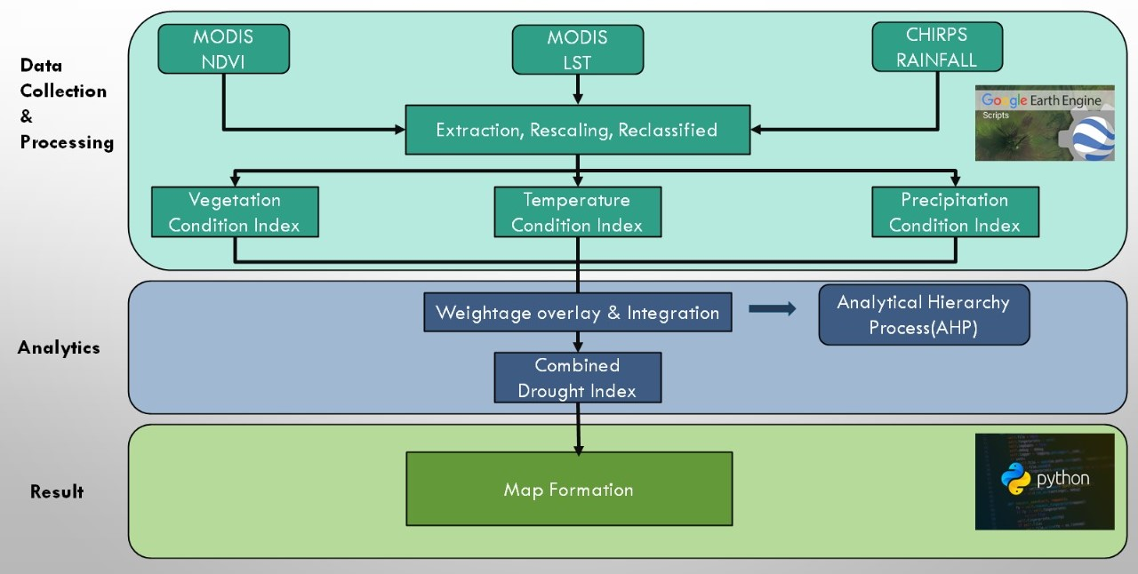

Figure 4.1: The fowchart of methodology used in the study

**For the monitoring agriculture drought above steps are performed.**

**For Vegetation Condition Index (VCI)**

The first step in calculating VCI is to acquire the necessary data, which includes satellite imagery that provides an estimate of the amount of photosynthetic activity taking place on the land surface. This is typically done using remote sensing data from sensors such as MODIS, AVHRR, or Landsat.

First, we download the datasets of NDVI of **MODIS** satellite data using google earth engine of year 2000 to 2023 for kharif seasonal months from July to October.

The next step is to calculate the VCI itself. This is done using a formula that compares the current NDVI (Normalized Difference Vegetation Index) value to the long-term average NDVI value for the same time period. The formula is expressed as follows:

VCI = (Current NDVI - Minimum NDVI) / (Maximum NDVI - Minimum NDVI) x 100

Where:

Minimum NDVI: the minimum NDVI value observed over a certain period. (01/07/2000 to 31/10/2023)

Maximum NDVI: the maximum NDVI value observed over a certain period. (01/07/2000 to 31/10/2023)

Current NDVI: the NDVI value for the current time period. (For a particular year).

Finally, the results of the VCI calculation are interpreted and analysed. This typically involves mapping the VCI over time and space to identify trends and patterns in vegetation stress levels. These patterns can then be used to inform decision-making around agricultural management, resource allocation, and emergency response planning.

And after perform this step our project’s one indices VCI (Vegetation condition index) is ready for the monitoring drought assessment.

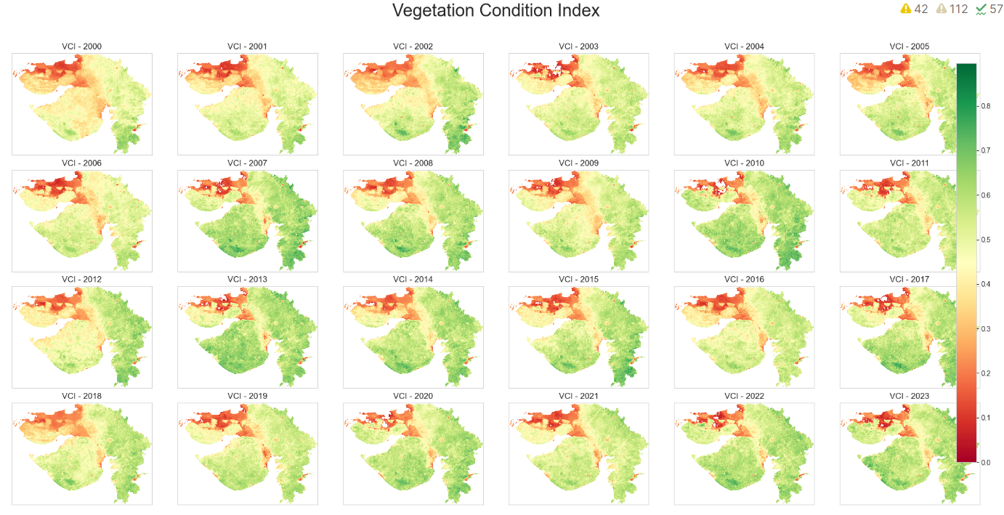

Figure:4.2 Yearwise VCI Variation (2000-2023)

**For Temperature Condition Index (TCI)**

The land surface temperature (LST) is an important variable used in the calculation of the temperature condition index (TCI), which is a commonly used index for assessing agricultural drought conditions.

second step is calculating TCI is to acquire the necessary data, which includes temperature data from weather stations or other sources, as well as satellite imagery that provides an estimate of the land surface temperature. This can be done using sensors such as MODIS, Landsat, or Sentinel.

First, we download the datasets of LST (Land Surface Temperature) of **MODIS** satellite data using google earth engine of year 2000 to 2023 for kharif seasonal months from July to October.

**TCI = (Maximum LST - LST) / (Maximum LST - Minimum LST) x 100**

Where:

Minimum LST: the minimum LST value observed over a certain period. (01/07/2000 to 31/10/2023)

Maximum LST: the maximum LST value observed over a certain period. (01/07/2000 to 31/10/2023)

Current LST: the LST value for the current time period. (For a particular year).

The Temperature Condition Index (TCI) based on land surface temperature (LST) is a useful tool for monitoring and assessing agricultural drought conditions. It provides insights into the level of temperature stress that crops and vegetation are experiencing and can assist in decision-making around agricultural management, resource allocation, and emergency response planning. However, the TCI should be used in conjunction with other indices and interpreted carefully in the context of other environmental factors that may affect agricultural productivity.

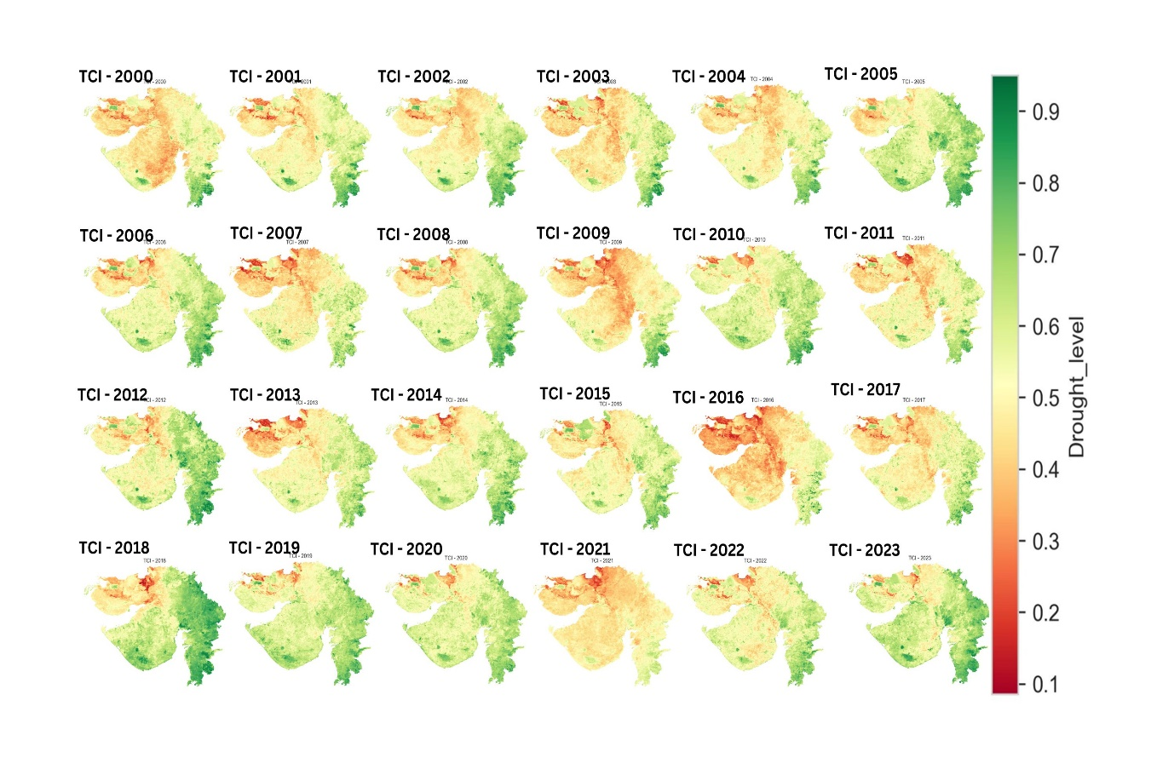

Temperature Condition Index

Figure:4.3 Yearwise TCI Variation (2000-2023)

**For Precipitation condition index(PCI):**

The Precipitation Condition Index (PCI) is a methodology used for agricultural drought assessment based on rainfall precipitation data. The PCI is calculated by comparing the current period's rainfall precipitation with the long-term average precipitation during the same period.

Now, we download the datasets rainfall precipitation data of **CHIRPS** satellite data using google earth engine of year 2000 to 2023 for kharif seasonal months from July to October.

The formula for PCI is calculated as follows:

**PCI = (Current rainfall precipitation - Minimum rainfall precipitation) / (Maximum rainfall precipitation - Minimum rainfall precipitation) x 100**

Where:

Current rainfall precipitation: the rainfall precipitation amount recorded during the current period

Minimum rainfall precipitation: the lowest rainfall precipitation amount observed during the same period in the long-term data record

Maximum rainfall precipitation: the highest rainfall precipitation amount observed during the same period in the long-term data record

The PCI provides a measure of the departure of current precipitation conditions from the long-term average, indicating the degree of deviation from normal precipitation conditions. The PCI values range between 0 and 1, with lower values indicating more severe drought conditions and higher value indicating normal or above-normal precipitation conditions.

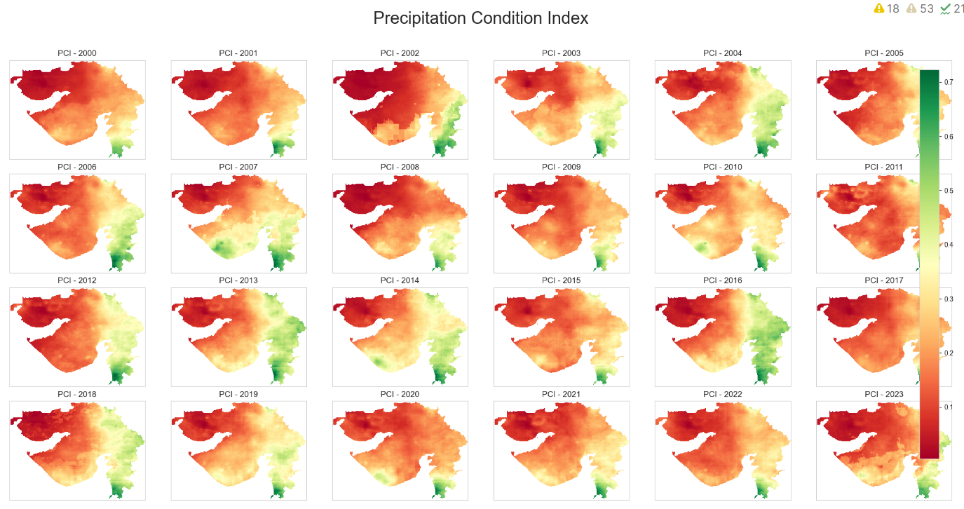

Figure:4.4 Yearwise PCI Variation (2000-2023)

Combined Drought Index Calculate In Google Earth Engine:

Weightage are determined the following procedure:

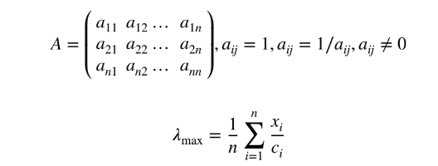

where A denotes pairwise comparison matrix where each factor is the proportion of weightage of the criteria, n is the number of criteria, and ci and xi are the weightage (com-parative degree of importance) and approximation of eigenvector.

The study utilizes the Analytical Hierarchy Process (AHP) to develop a Combined Drought Index (CDI) for assessing Kharif season drought severity in Gujarat region. Pairwise comparison matrices are created, and consistency is evaluated using the Consistency Ratio (CR). Criteria determination is challenging due to the reliance of rabi crops on soil residual moisture. Decision makers assign high weightage to Vegetation Condition Index (VCI) based on their significance in crop vigor and growth. The CR value (4.2%) indicates the consistency of the pairwise comparison matrix. CDI maps are generated by integrating weighted overlaid variables, providing a single index map representing drought severity. Three drought years (2002, 2006, and 2016) and three normal years (2003, 2012, and 2017) are selected based on mean CDI values at the district level for further analysis of spatial and seasonal drought variability.

**VCI 🡪 0.33**

**PCI 🡪 0.53**

**TCI 🡪 0.14**

And then staked together according to the given formula below:

**Combined Drought Index = (0.33*VCI) +(0.14*PCI) +(0.53*TCI)**

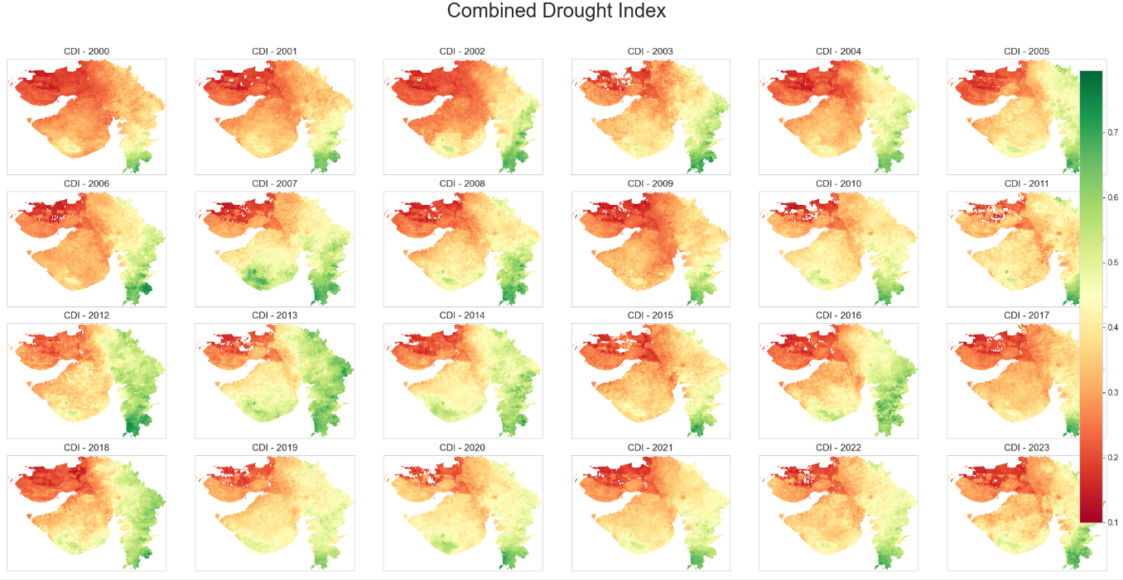

Figure:4.5 Yearwise CDI Variation (2000-2023)

**Table:4.1** Formulas for the Indices.

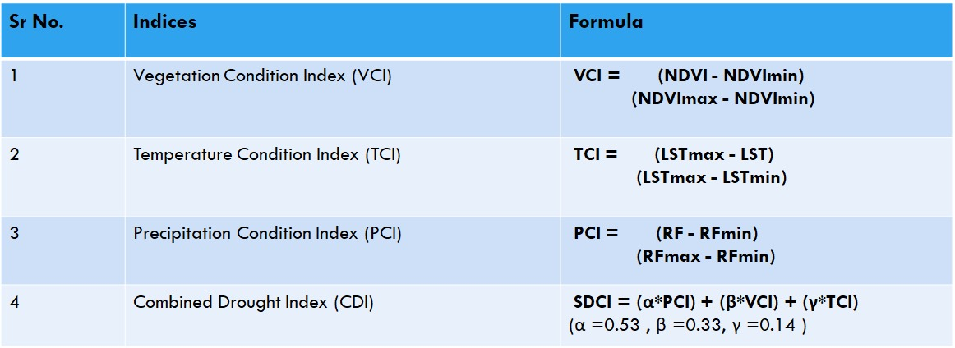

**Evaluate Drought Categories**

**Table 4.2** *Classification of Drought by calculated the CDI,TCI,VCI,PCI*

|  |  |  |  |
| --- | --- | --- | --- |
| |  | | --- | | **Drought Categories** | | **CDI,TCI,VCI,**  **Values** | **PCI Value** |
| Extreme Drought | 0<CDI,TCI,VCI<0.1 | 0<PCI<0.1 |
| Severe Drought | 0.1<CDI,TCI,VCI<0.2 | 0.1<PCI<0.2 |
| Moderate Drought | 0.2<CDI,TCI,VCI<0.3 | |  | | --- | | 0.2<PCI<0.3 | |
| Mild Drought | 0.3<CDI,TCI,VCI<0.4 | 0.3<PCI<0.4 |
| Near Normal | 0.4<CDI,TCI,VCI<0.6 | 0.4<PCI<0.5 |
| Non Drought | 0.6<CDI,TCI,VCI<1 | 0.5<PCI<1 |

**5. Results**

In Gujarat 2000, 2001, 2002, 2004, 2009, 2016 are drought years while others are non drought years.

In the Drought Year:

Severe drought regions :- Kachchh, SabarKantha, Banaskantha, Saurashtra

Moderate drought region :- Middle Gujarat

Normal region :- Valsad, Navsari, Surat, Panchmahal and Dang Region.

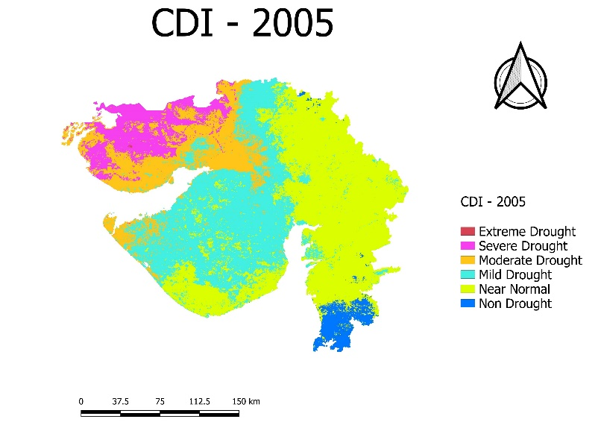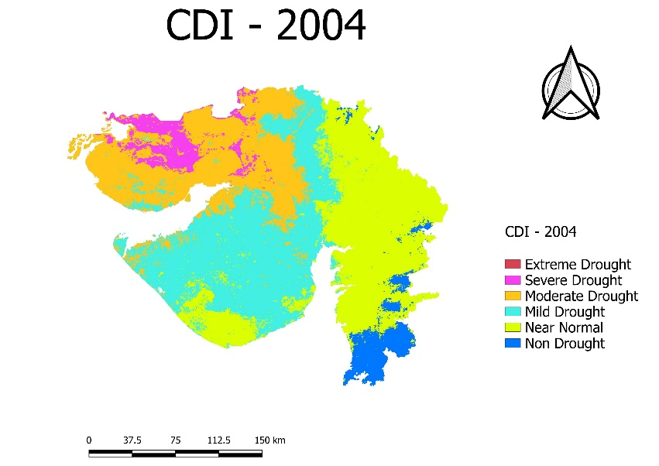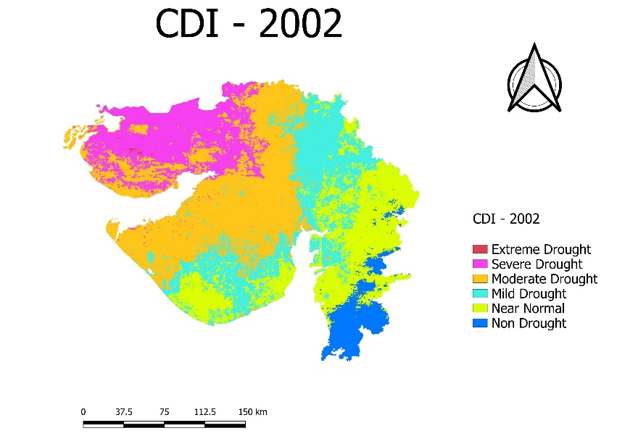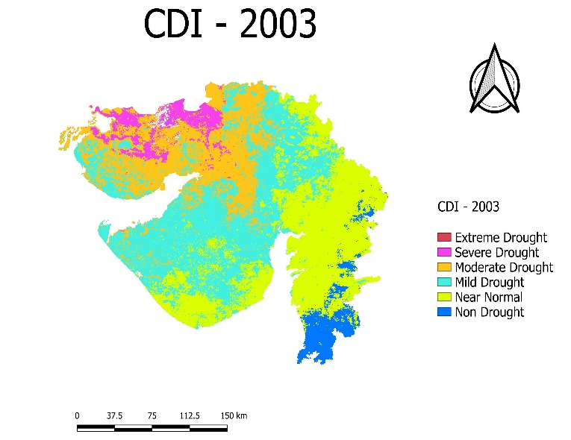

Normal Year

Drought Year

Figure:5.1 Drought Year v/s Normal Year

This table shows the mean Combined Drought Index values district-wise. We found severe drought in the Kachchh region, severe to moderate drought in the Saurashtra region and North Gujarat, while districts in South Gujarat are experiencing lower levels of drought.

Table:5.1 Mean Combined Drought Index values by district for drought monitoring.

|  |  |  |  |  |  |  |  |  |  |
| --- | --- | --- | --- | --- | --- | --- | --- | --- | --- |
| State | District | 2000 | 2001 | 2002 | 2003 | 2004 | 2005 | 2009 | 2016 |
| Gujarat | Ahmadabad | 0.3 | 0.3 | 0.39 | 0.33 | 0.35 | 0.35 | 0.38 | 0.37 |
| Gujarat | Amreli | 0.33 | 0.41 | 0.39 | 0.38 | 0.39 | 0.44 | 0.38 | 0.43 |
| Gujarat | Anand | 0.35 | 0.38 | 0.53 | 0.41 | 0.5 | 0.47 | 0.4 | 0.52 |
| Gujarat | Banas Kantha | 0.25 | 0.37 | 0.40 | 0.33 | 0.35 | 0.36 | 0.3 | 0.41 |
| Gujarat | Bharuch | 0.38 | 0.42 | 0.59 | 0.4 | 0.42 | 0.4 | 0.3 | 0.43 |
| Gujarat | Bhavnagar | 0.31 | 0.39 | 0.42 | 0.37 | 0.36 | 0.42 | 0.39 | 0.41 |
| Gujarat | Dahod | 0.45 | 0.47 | 0.48 | 0.48 | 0.51 | 0.47 | 0.45 | 0.62 |
| Gujarat | Gandhinagar | 0.28 | 0.32 | 0.30 | 0.35 | 0.25 | 0.32 | 0.27 | 0.29 |
| Gujarat | Jamnagar | 0.32 | 0.31 | 0.26 | 0.37 | 0.33 | 0.33 | 0.37 | 0.3 |
| Gujarat | Junagadh | 0.4 | 0.41 | 0.45 | 0.38 | 0.48 | 0.41 | 0.33 | 0.53 |
| Gujarat | Kachchh | 0.15 | 0.16 | 0.15 | 0.28 | 0.2 | 0.25 | 0.27 | 0.25 |
| Gujarat | Kheda | 0.41 | 0.38 | 0.52 | 0.4 | 0.46 | 0.44 | 0.4 | 0.55 |
| Gujarat | Mahesana | 0.31 | 0.37 | 0.42 | 0.35 | 0.4 | 0.47 | 0.41 | 0.43 |
| Gujarat | Narmada | 0.45 | 0.62 | 0.61 | 0.64 | 0.69 | 0.57 | 0.67 | 0.53 |
| Gujarat | Navsari | 0.66 | 0.69 | 0.65 | 0.64 | 0.65 | 0.6 | 0.7 | 0.68 |
| Gujarat | Panch Mahals | 0.33 | 0.37 | 0.52 | 0.5 | 0.48 | 0.45 | 0.36 | 0.57 |
| Gujarat | Patan | 0.28 | 0.32 | 0.44 | 0.29 | 0.39 | 0.41 | 0.27 | 0.4 |
| Gujarat | Porbandar | 0.36 | 0.35 | 0.36 | 0.4 | 0.38 | 0.3 | 0.31 | 0.37 |
| Gujarat | Rajkot | 0.34 | 0.42 | 0.35 | 0.4 | 0.38 | 0.35 | 0.37 | 0.34 |
| Gujarat | Sabar Kantha | 0.35 | 0.4 | 0.49 | 0.44 | 0.39 | 0.48 | 0.36 | 0.37 |
| Gujarat | Surat | 0.59 | 0.58 | 0.77 | 0.51 | 0.54 | 0.51 | 0.53 | 0.7 |
| Gujarat | Surendranagar | 0.25 | 0.28 | 0.27 | 0.3 | 0.34 | 0.31 | 0.27 | 0.28 |
| Gujarat | The Dangs | 0.71 | 0.66 | 0.60 | 0.68 | 0.74 | 0.64 | 0.66 | 0.67 |
| Gujarat | Vadodara | 0.42 | 0.44 | 0.61 | 0.53 | 0.51 | 0.45 | 0.4 | 0.66 |
| Gujarat | Valsad | 0.73 | 0.71 | 0.58 | 0.67 | 0.66 | 0.67 | 0.73 | 0.63 |

**6. Conclusion**

The agriculture drought project based on VCI, TCI, and PCI indices is a useful approach to monitor and assess drought conditions in agricultural areas. By using these indices, it is possible to estimate the vegetation condition, temperature, and precipitation anomalies, respectively, which are critical factors for agricultural productivity. The project offers several advantages, including its ability to provide early warnings of drought conditions and to assess the severity and duration of the drought.

Moreover, the use of remote sensing and satellite data enables the project to cover vast areas, including remote and inaccessible regions, providing an accurate and reliable assessment of drought conditions. The project's data can also be integrated with other climate and environmental data to provide a more comprehensive understanding of drought impacts. The project can provide valuable information for decision-makers in the agriculture sector, enabling them to take appropriate actions to mitigate the impacts of drought, such as adjusting planting schedules, implementing irrigation measures, and providing targeted support to affected communities.

For the better result you can also try a different type of algorithms by a use of different plugging tools which is provided by a different remote sensing software’s.

Overall, the use of VCI, TCI, and PCI indices in the agriculture drought project is a valuable tool for monitoring and assessing drought conditions in agricultural areas, and can help to improve food security and livelihoods in vulnerable communities.

**7. References**

Agricultural drought monitoring: Progress, challenges, and prospects.

* <https://www.researchgate.net/publication/301720744_Agricultural_drought_monitoring_Progress_challenges_and_prospects>

Monitoring of agricultural drought in semi-arid ecosystem of Peninsular India through indices derived from time-series CHIRPS and MODIS datasets.

* <https://www.sciencedirect.com/science/article/pii/S1470160X20309729>

Dipanwita Dutta, Arnab Kundu, N.R. Patel, S.K. Saha (2015) Assessment of agriculture drought in Rajasthan using remote sensing derived vegetation condition index and standardized precipitation index.

* <https://www.sciencedirect.com/science/article/pii/S1110982315000095>

N.R. Patel, B.R. Parida, V. Venus, S.K. Saha, V.K. Dadhwal (2012) Analysis of agricultural drought using vegetation temperature condition index (VTCI) from Terra/MODIS satellite data

* <https://pubmed.ncbi.nlm.nih.gov/22200944/>

S.K. Jain, R. Keshri, A. Goswami, A. Sarkar (2010) Application of meteorological and vegetation indices for evaluation of drought impact: a case study for Rajasthan, India

* <https://www.researchgate.net/publication/225613907_Application_of_meteorological_and_vegetation_indices_for_evaluation_of_drought_impact_A_case_study_for_Rajasthan_India>

F.N. Kogan (1995) Application of vegetation index and brightness temperature for drought detection.

* <https://www.sciencedirect.com/science/article/abs/pii/027311779500079>

Abhishek Danodia, Anuradha Kushwaha,N. R. Patel:Remote sensing‐derived combined index for agricultural drought assessment of rabi pulse crops in Bundelkhand region, India

* <https://link.springer.com/article/10.1007/s10668-021-01305-3>

Venkatesh Ravichandran , Komali Kantamaneni, Thilagaraj Periasamy, Priyadarsi D. Roy, Jothiramalingam Killivalavan, Sajimol Sundar, Lakshumanan Chokkalingam and Masilamani Palanisamy(2022): Monitoring of Multi-Aspect Drought Severity and Socio-Economic Status in the Semi-Arid Regions of Eastern Tamil Nadu, India

* <https://www.researchgate.net/publication/361592843_Monitoring_of_Multi-Aspect_Drought_Severity_and_Socio-Economic_Status_in_the_Semi-Arid_Regions_of_Eastern_Tamil_Nadu_India>

E. M. Ergene , F. Bektaş Balçık , F. Balik Şanlı(2024): Trends Analysis of agricultural drought in central anatolian basin, Turkey.

* <https://isprs-archives.copernicus.org/articles/XLVIII-4-W9-2024/141/2024/>